roject One: Milestone 3A – Cover Page
Team Number: | Tues-35
Please list full names and MacID’s of all present Team Members
Full Name: | MacID:
Joshua McMullin | mcmullij
Sami Alrejleh | alrejles
Oguntunde Olorunloluwa | ogunto1
Zareen Kabir | kabirz

Milestone 3A (stage 1) – Material Selection: problem definition
Team Number: | Tues-35

- Copy-and-paste the title of your assigned scenario in the space below.
Roof Generator

- MPI selection
  - List one primary objective and one secondary objective in the table below
  - For each objective, list the MPI
  - Write a short justification for your selected objectives
 | Objective | MPI-stiffness | MPI-strength | Justification for this objective
Primary | Minimize Cost | $$\frac{E}{pC_{m}}$$ | $$\frac{σ_{y}}{pC_{m}}$$ | Due to the goal of homeowners purchasing this turbine is to reduce the cost they pay on electricity, the initial investment of buying the turbine should be as little as possible. As this objective matches the goal of the turbine, it is made primary to reflect that.
Secondary | Minimize Volume | $$E$$ | $$σ_{y}$$ | Since this turbine must go on top of residential homes, it must be of relatively small size in order to satisfy this requirement.

Milestone 3A (stage 2) – Material Selection: MPI and material ranking

Document the results of your materials selection and ranking on the following page.
- Each team member is required to complete this on the INDIVIDUAL worksheet document, and then copy-and-paste to this document

We are asking that you submit your work on both worksheets. It does seem redundant, but there are valid reasons for this:
- Each team member needs to submit their summary of material property charts with the Milestone Three-A Individual Worksheets document so that it can be graded
- Compiling your individual work into this Milestone Three-A Team Worksheets document allows you to readily access your team member’s work
  - This will be especially helpful when completing Stage 3 of the milestone

Team Number: | Tues-35

Copy-and-paste from the INDIVIDUAL worksheet
Full Name: | MacID:
Joshua McMullin | mcmullij

Material Property Chart
Assigned MPI #1 | Functional Constraint | Objective
 | d < d* | Minimize Cost - MPI stiffness
Insert a screenshot of the material property chart with MPI guideline. Please clearly label the top 5 materials with their name in the plot.

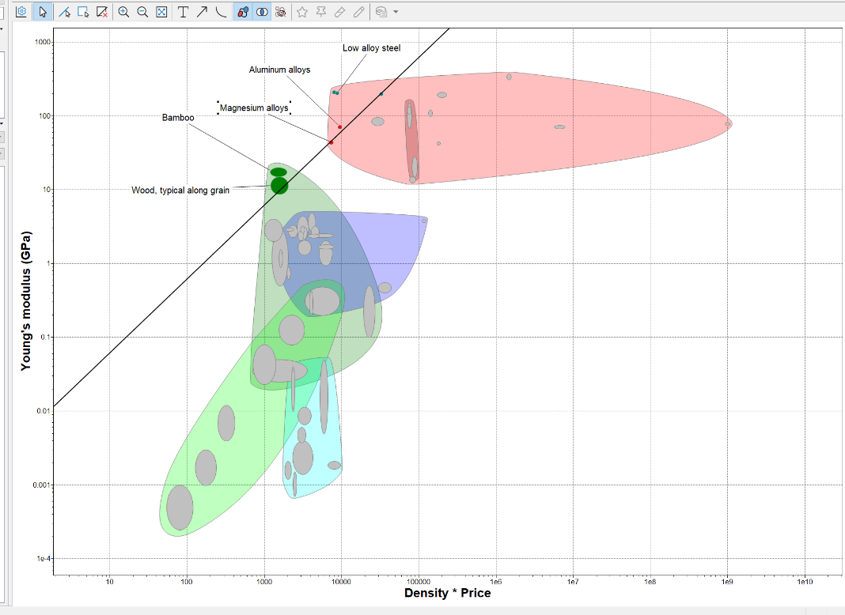

Team Number: | Tues-35

Copy-and-paste from the INDIVIDUAL worksheet
Full Name: | MacID:
Oguntunde Olorunloluwa | ogunto1  Ogunto1

Material Property Chart
Assigned MPI #2 | Functional Constraint | Objective
$$\frac{σ_{y}}{pC_{m}}$$ | d < d* | Minimise cost(MPI Strength)
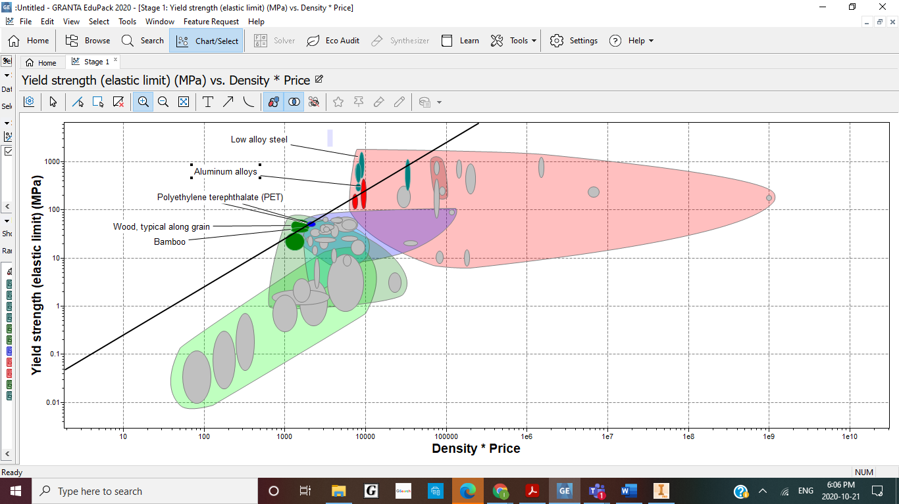

Team Number: | 35

Full Name: | MacID:
Zareen Kabir | kabirz

Material Property Chart
Assigned MPI | Functional Constraint | Objective
E | d < d* | Minimize Volume
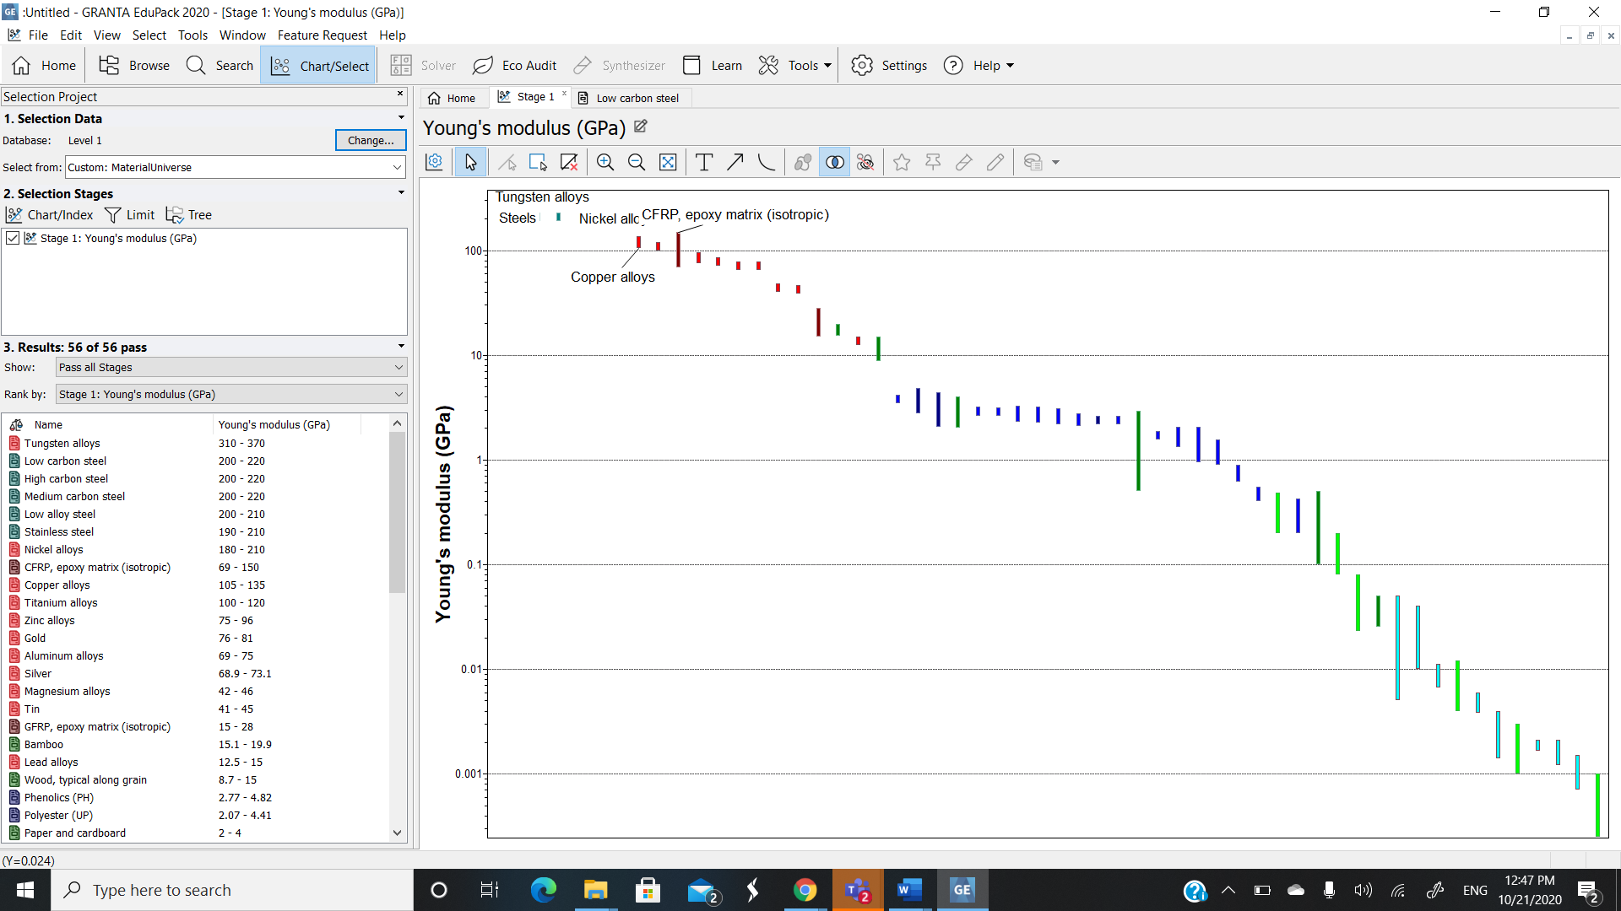

Team Number: | 35

Copy-and-paste from the INDIVIDUAL worksheet
Full Name: | MacID:
Sami Alrejleh | alrejles

Material Property Chart
Assigned MPI #4 | Functional Constraint | Objective
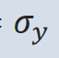 | d < d* | Minimize Volume
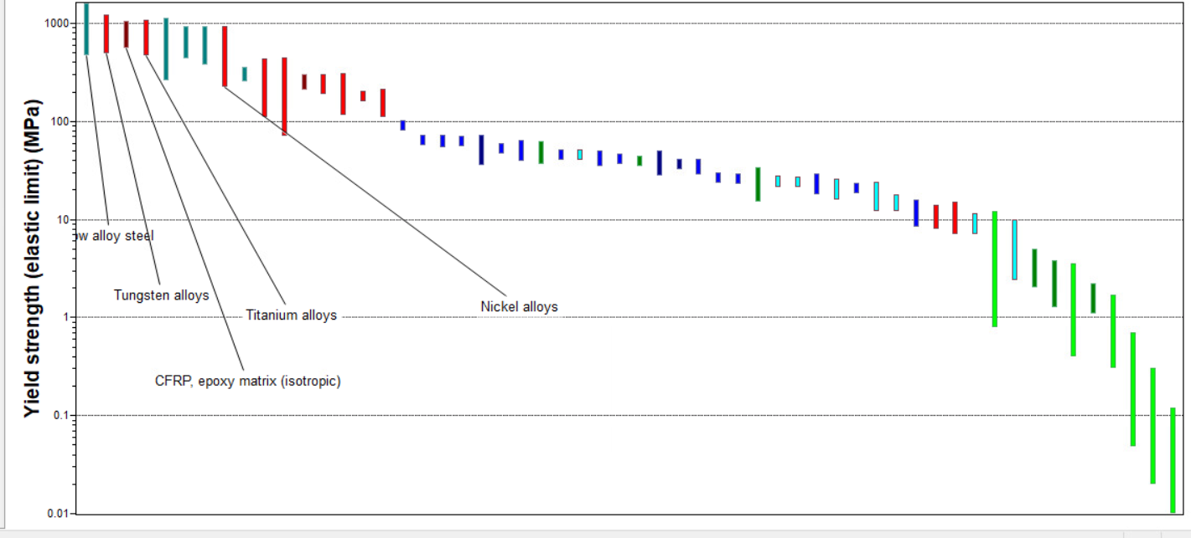

*If you are in a team of 5, please copy and paste the above on a new page

Milestone 3A (stage 3) – Material Selection: material alternatives and final selection
Team Number: | 35

Consolidation of Individual Material Rankings
 | Rank 1 | Rank 2 | Rank 3 | Rank 4 | Rank 5
 | Material Name | Material Name | Material Name | Material Name | Material Name
E/pCm - stiffness | Steels | Bamboo | Aluminum Alloys | Wood, typical along grain | Magnesium Alloys
$$\frac{σ_{y}}{pC_{m}}$$ | Steels | Wood,typical grain | Bamboo | Polyethylene terephthalate | Aluminium Alloys
E-stiffness | Tungsten alloys | Steels  (Low carbon steel) | Nickel alloys | CFRP, epoxy matric (isotropic) | Copper alloys
$$σ_{y}$$ | Steels | Tungsten Alloys | Titanium Alloys | CFRP, epoxy matrix (isotropic) | Nickel Alloys

Narrowing Material Candidate List to 3 Finalists
Material Finalist 1: | Steels
Material Finalist 2: | Tungsten Alloys
Material Finalist 3: | Bamboo

Team Number: | 35

Compare Material Alternatives and Make a Final Selection using a Decision Matrix
- As a team, establish a weighting factor for each criterion:
  - Move row-by-row
    - If Criteria 1 is preferred over Criteria 2, assign a 1. Otherwise, assign 0
    - If Criteria 1 is preferred over Criteria 3, assign a 1. Otherwise, assign 0
  - Add additional rows/columns as needed
Criteria Ranking
 | Durability | Price | Yield Strength |  |  |  | Weight factor
Longevity | 1 | 0 | 0 |  |  |  | 1
Price | 1 | 1 | 0 |  |  |  | 2
Yield Strength | 1 | 1 | 1 |  |  |  | 3

- As a team, evaluate your materials against each criterion using your weighting
  - Add additional rows as needed
Decision Matrix
 | Weight factor | Steels |  | Tungsten Alloys |  | Bamboo
 | Weight factor | Rating | Weighted Rating | Rating | Weighted Rating | Rating | Weighted Rating
Longevity | 1 | 2 | 2 | 3 | 3 | 2 | 4
Price | 2 | 3 | 6 | 1 | 2 | 2 | 4
Yield Strength | 3 | 3 | 9 | 2 | 6 | 1 | 3
TOTAL |  | 8 | 17 | 6 | 11 | 5 | 11

Team Number: | 35

- List your chosen material and justify your selection
Justification
List Chosen Material: | Steels(Low alloy steel)
Our criteria were longevity, price, and yield strength.

We ranked tungsten alloys above steel and bamboo because researched and tungsten lasts long. Also, steel rusts, while tungsten does not. Steel can still last for a sufficient amount of time. However, bamboo can last for a sufficient amount of time as well, even in harsh weather conditions. Therefore, we ranked steel and bamboo as the same for longevity (which is below tungsten alloys).

Steel was ranked the highest in Price as it is the cheapest material according to the MPI value. This is a result of Steel being easily accessible. Canada is also a producer of steel, whereas the other materials would need to be exported. This overall results in steel being the preferred choice according to price.

Steels were ranked highly among other materials when comparing the yield strength, with Tungsten alloys being the following, and bamboo being the weakest in terms of yield strength when compared to the alloys. Steels were chosen over Tungsten alloys and bamboo due to their high yield strength.

When following our weighted rankings, steel clearly is the winner, as it finished with 6 points higher than both tungsten and bamboo.

Summary of Chosen Material’s Properties
Material Name: | Average value:
Young’s modulus $E$ (GPa): | 200-210
Yield Strength $σ_{y}$ (MPa): | 469-1.6e3
Tensile strength $σ_{UTS}$ (MPa): | 699-1.8e3
Density $ρ$ (kg/m³): | 7.8e3
Embodiment Energy $H_{m}$ (MJ/kg) | 29.5-32.6
Specific carbon footprint ${CO}_{2}$ (kg/kg) | 2.37-2.61

